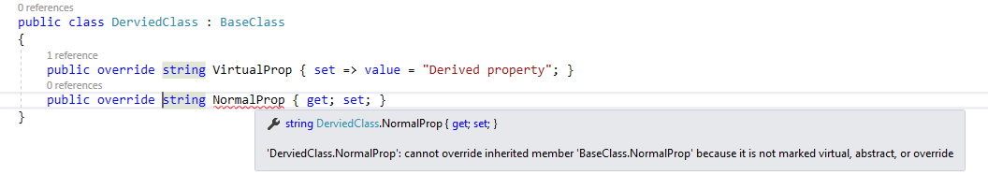

The virtual keyword is used to modify a method, property, indexer, or event declared in the base class and allow it to be overridden in the derived class.

The override keyword is used to extend or modify a virtual/abstract method, property, indexer, or event of base class into derived class.

The new keyword is used to hide a method, property, indexer, or event of base class into derived class.